|  |
| --- |
| **OrangeHR-Directory and Maintanace Live Project** |
| **Project Functional Requirement Specification Version 1** |
|  |
| **Prepared by:Rajasekhar reddy B**  **Reviwed by:Raghavendra BN** |
|  |

|  |
| --- |
|  |

Contents

1. Purpose of the document: 3

2. Project Overview: 3

2.1 Audience: 3

2.2 Hardware and software components: 3

9.Directory....................................................................................................................................................4

9.1Name...................................................................................................................................................4

9.2 Job title 5

9.3Location...............................................................................................................................................5

10 .MAINTANANCE......................................................................................................................................6

10.1 Purge records.....................................................................................................................................6

10.1.1 Employee records......................................................................................................................7

10.1.2 candidate records.......................................................................................................................7

10.2 Access records..................................................................................................................................7

11.SIGNOFF DOCUMENT..............................................................................................................................8

1.Purpose of the document:

This is a project plan. It is a guide for system architecture and development, not forphasing, timelines or deliverables.

This document is divided into three sections:

• Project Overview

• Information Architecture

• Site Design

# 2.Project Overview:

## 2.1 Audience:

This document is intended as a complete guide for admin in using OrangeHRM 3.0. This

document is specially designed for non-specialists; specialists may find the document a useful point of reference. By reading this guide, you will learn how to use OrangeHRM through the elements of the graphical user interface and what's behind some of the advanced features that are not always obvious at first sight. It will hopefully guide you around some common problems that frequently appear for users of OrangeHRM.

## 2.2 Hardware and software components:

OrangeHRM’s servers will be hosted at X company’s site.

OrangeHRM will be hosted on two servers: One to host the actual website and (language)code, and the other to host the (database name)database.

9.DIRECTORY

9.1 NAME

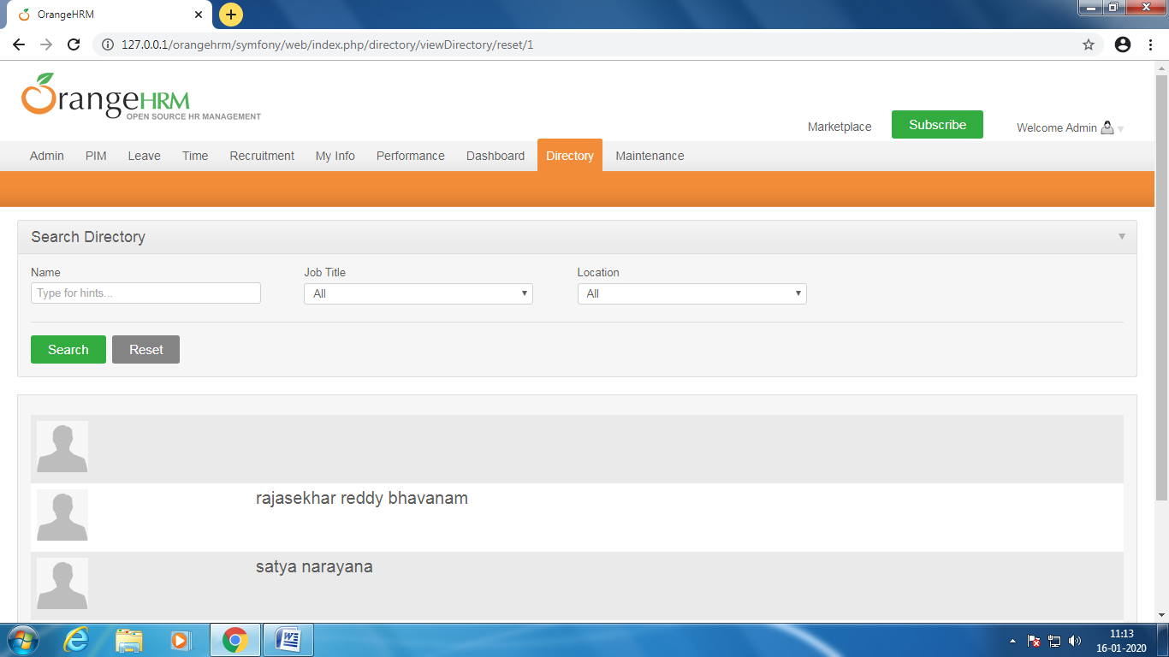

Fig9.1

First we enter the first name and middle name and next last name

9.2 JOB TITLE

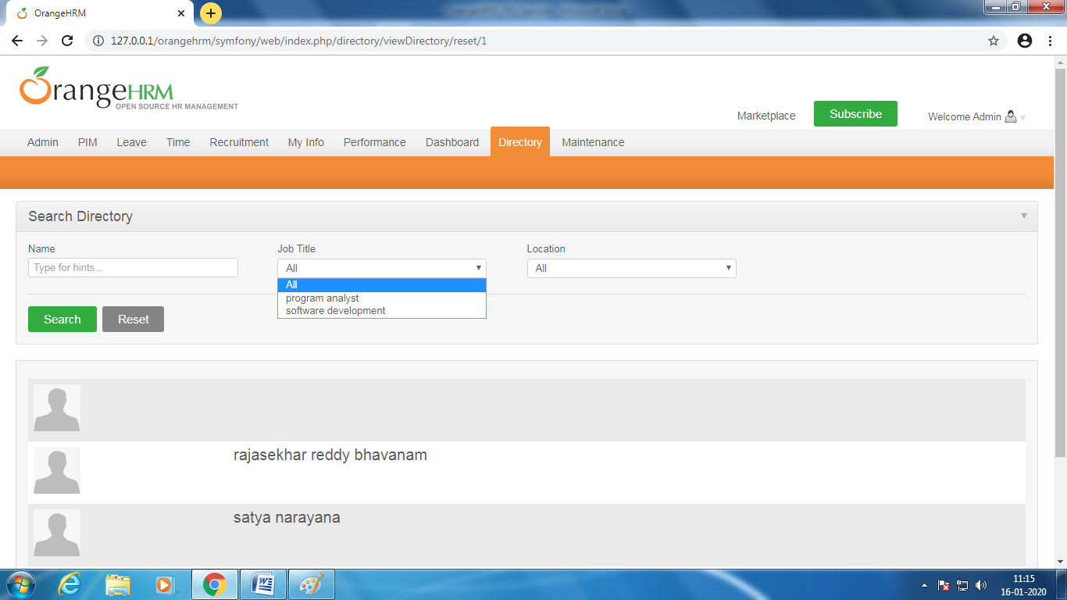

Fig9.2

we choose the job title like given below options in job title

9.3 location

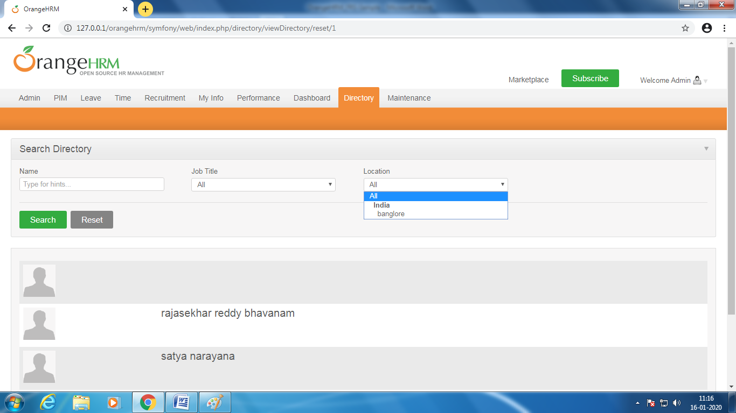

Fig9.3

Select the location in the location below options an then select the search to display the name and title and location

10.Maintance

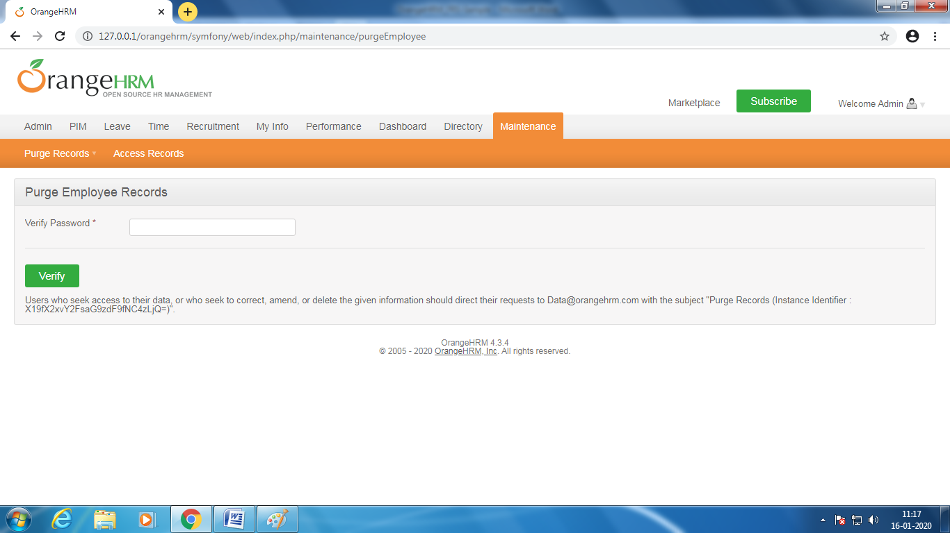

Fig10

In maintance there are two one is purge records and second one access records

10.1purge records

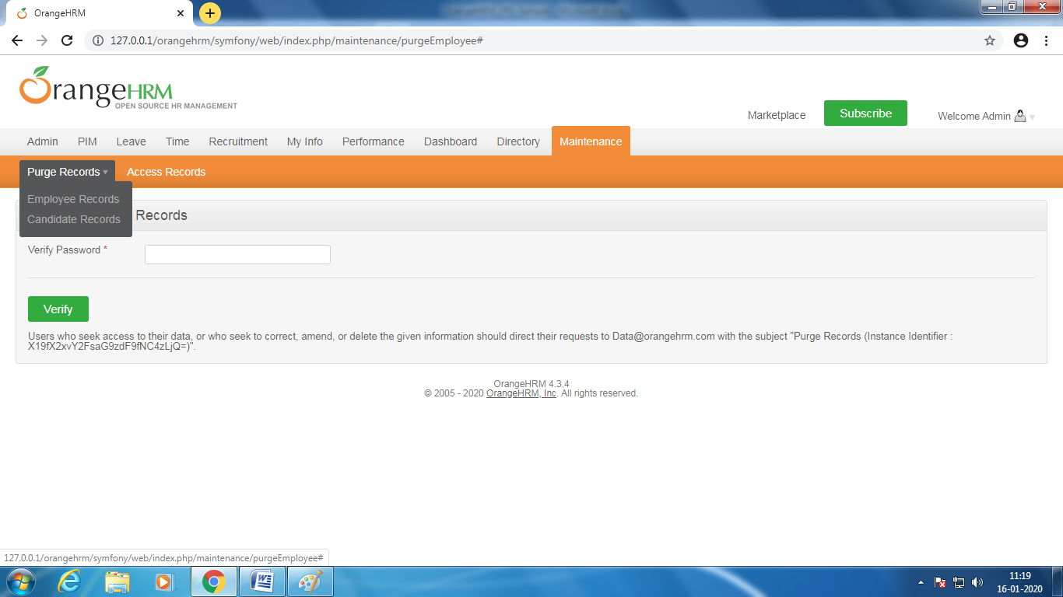

Fig10.1

In purge records we can enter the employee records and candidate records then we enter the password and click the verify

10.1.1 employee records

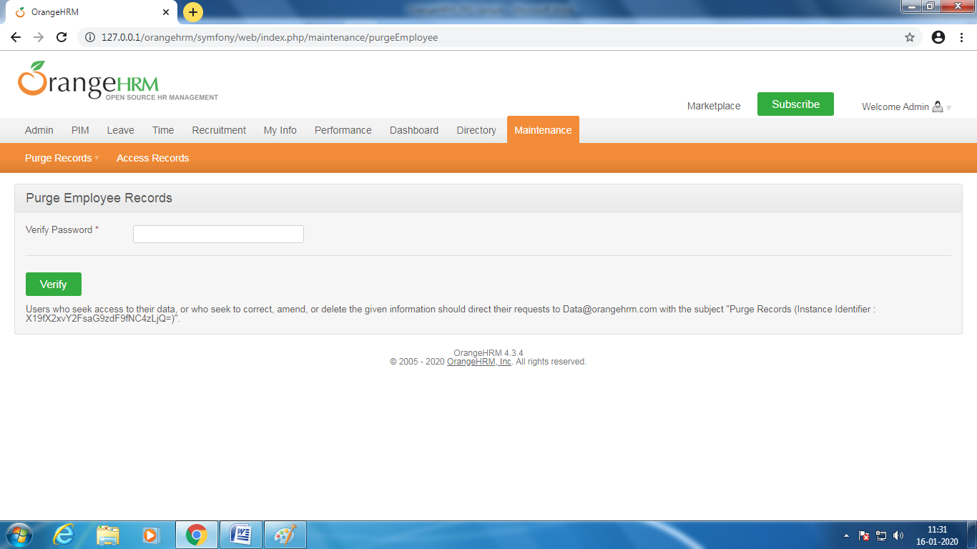

Fig10.1.1

We want the employee records can enter the password and check the records

10.1.2 candidate records

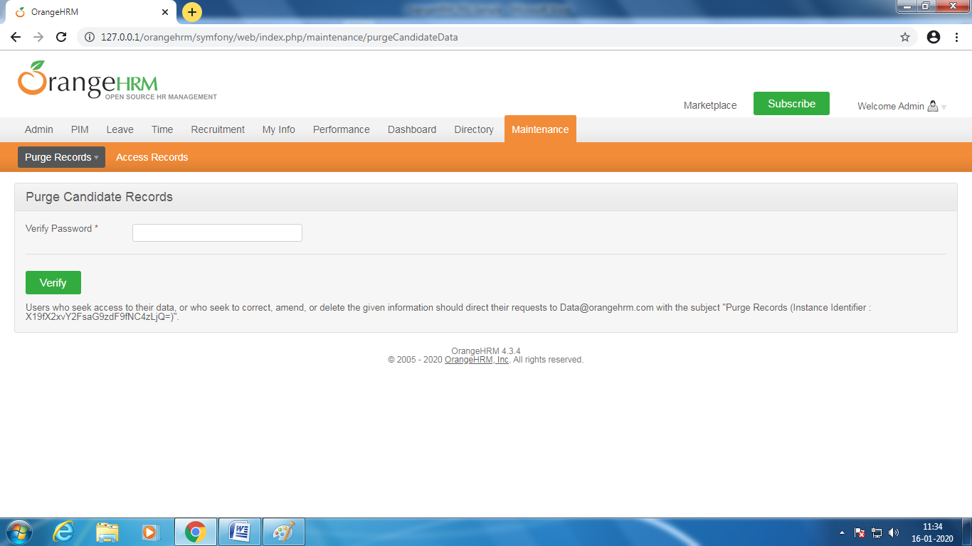

Fig10.1.2

We want the candidate records enter the password and check the record of canditate

10.2 acess records

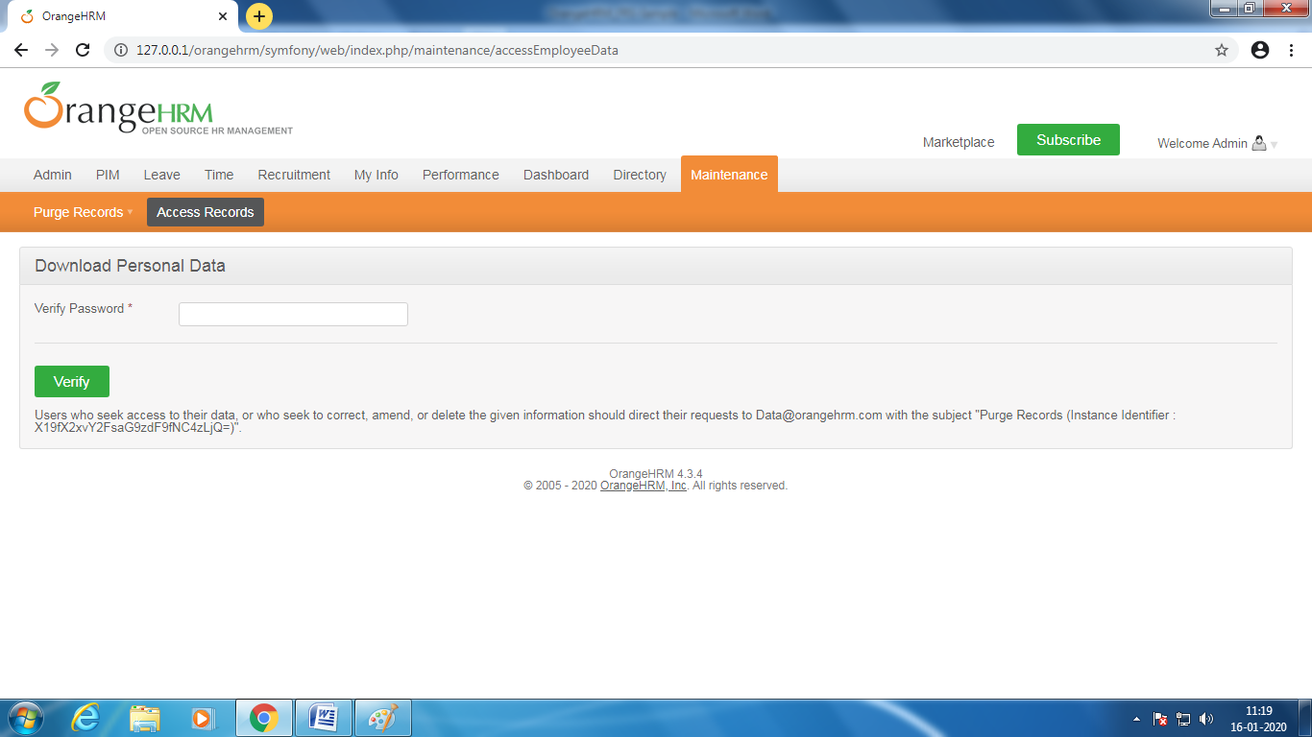

Fig10.2

If we want the download the personal data can enter the password and collect the personal data

# 11.Sign-Off Document

_____________________________________________________________________________

The following parties have read and agree with this Requirements Definition document for the OrangeHRM application account module functionality.

After approval of this Requirements Definition phase, any significant changes in the scope of this project will require validation of existing project costs and schedules.

_______________________________________________________________________

Name Date

Business Lead

______________________________________________________________________

Name Date

Project Manager

**Prepared by: Rajasekhar reddy B**